1. Install nginx and run nginx on port number 81

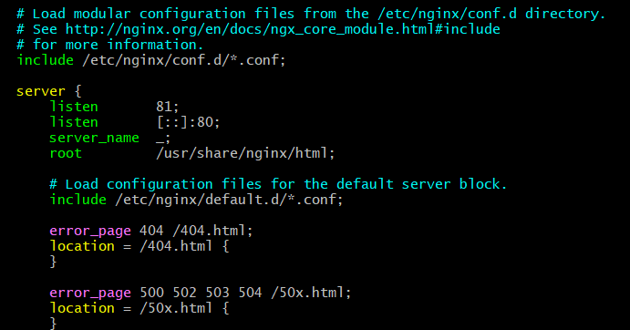

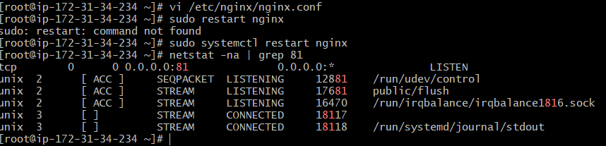

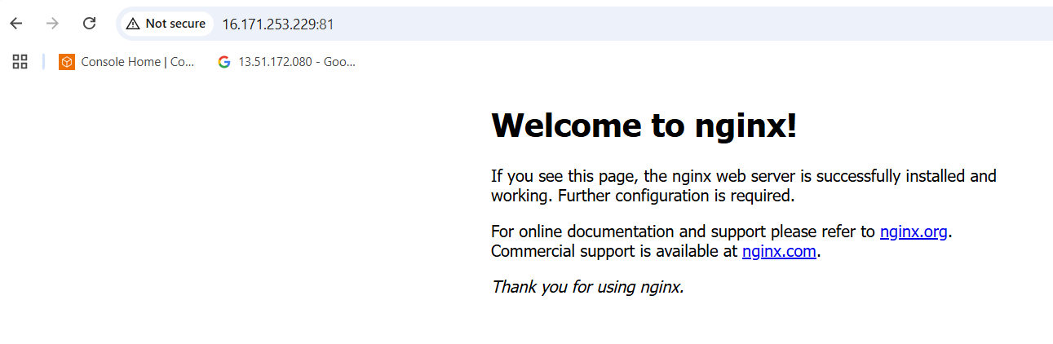

1. Deploy a sample index.html file on nginx.

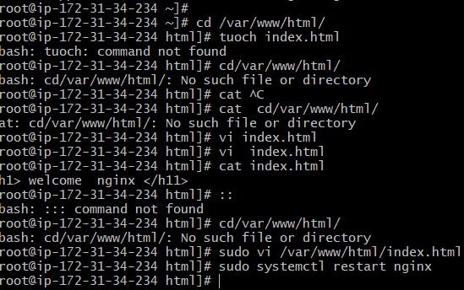

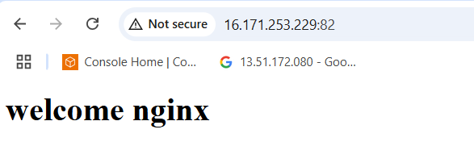

1. Install Apache and run Apache on port number 82

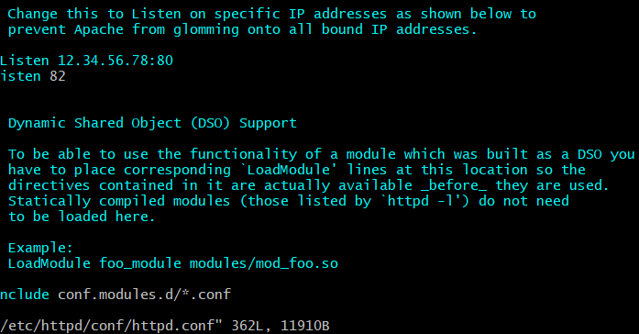

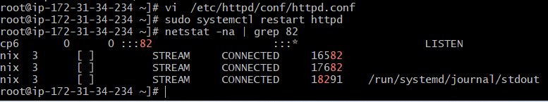

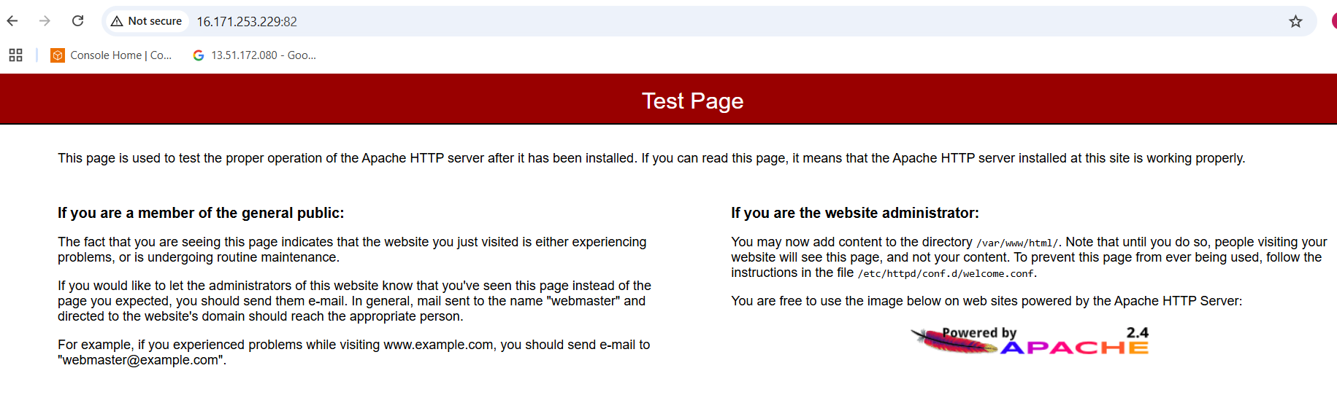

1. Deploy a sample index.html file on Apache.

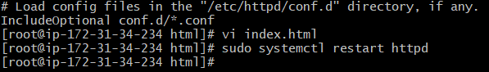

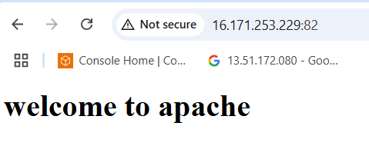

1. Install Apache tomcat on port number 8082

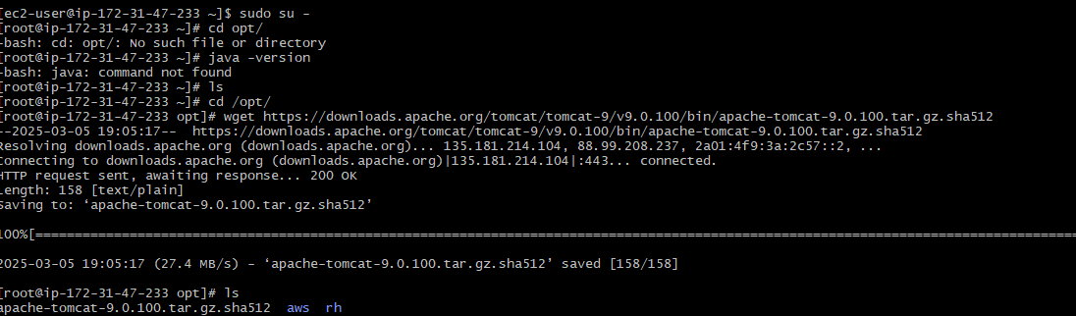

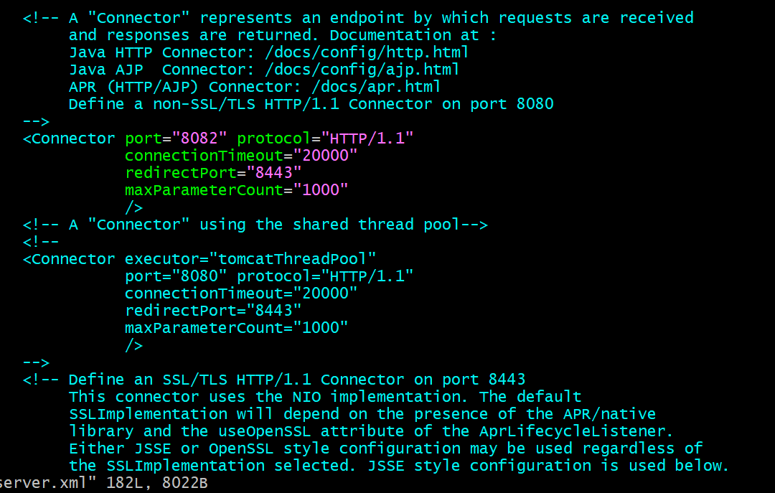

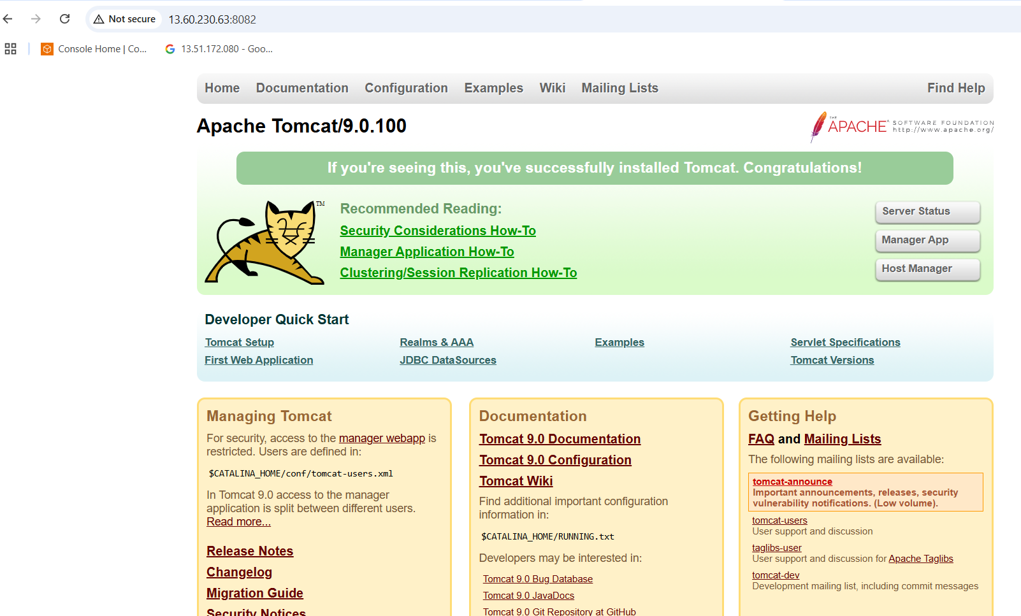

1. Deploy a sample app on webapps

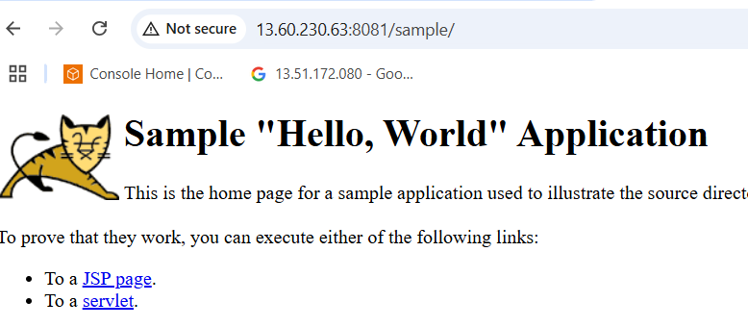

1. Create a tomcat.service file for tomcat.

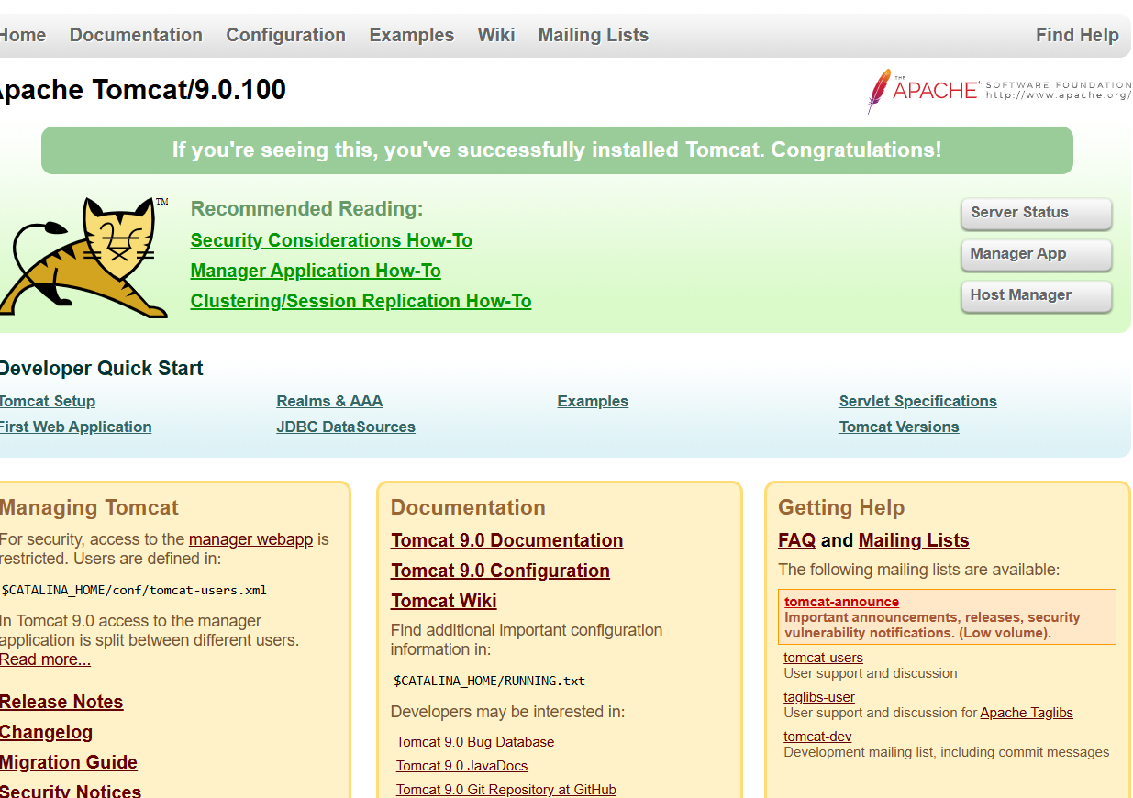s

1. Configure HA Proxy server

Launch 3 ec2 instants server1,server2,Ha-proxy -server

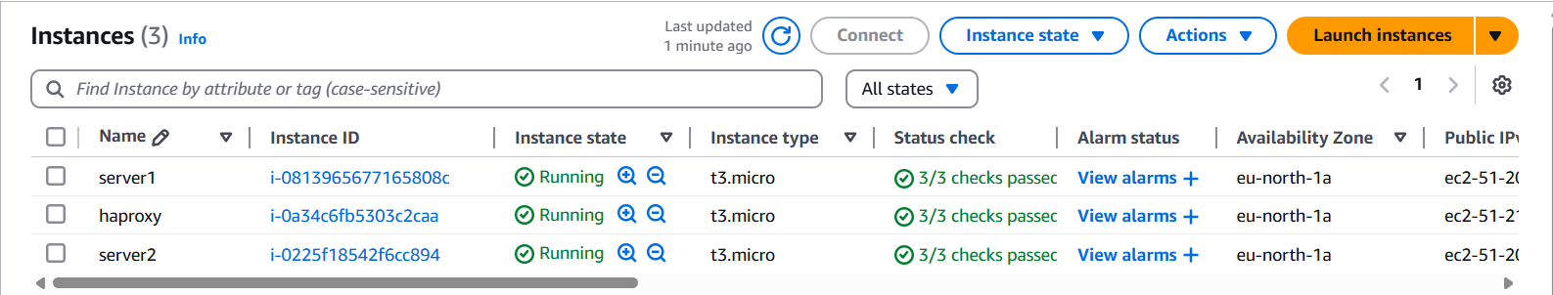

Server1 ec2

First connect to server1 ec2 instance using git bash